**A PROJECT REPORT ON**

"CUBICS"

**Prepared by**

## Rajdeep Singh (U42000001890)

**Under the guidance of**

## Prof. Poonam Chakravarty

**Submitted in**

## Partial Fulfillment of the Requirements for the Degree of Bachelor of Technology in Information Technology

**Submitted at**



# JUNE 2022

# DEPARTMENT OF CSE/IT

**RAI SCHOOL OF ENGINEERING**

**SARODA, DHOLKA - 382225**

# DIST: AHMEDABAD, GUJARAT

# RAI SCHOOL OF ENGINEERING

|  |
| --- |
|  |



**CERTIFICATE**

This is to certify that Mr. **Rajdeep Singh** of B.Tech. Semester VIII (Information Technology) has completed her project work titled **“Cubics”** satisfactorily in partial fulfillment of the requirement of **Bachelor of Technology** degree of **Information Technology**, **Rai University, Saroda, Ahmedabad** in the year 2022.

### Internal Guide Head of Department

Prof. Poonam Chakravarty Dr. Sailesh Iyer

Assistant Professor

### CSE/IT Department CSE/IT Department

**Date: Date:**

# ACKNOWLEDGEMENT

|  |
| --- |
|  |

Apart from the efforts of mine, the success of any project depends largely on the encouragement and guidelines of many others. I take this opportunity to pen down and express my gratitude to the people who have been instrumental in the successful completion of this project.

During this Project, I gained a good experience of real work, which is completely different from the academics. Moreover, this Project can be considered as the final step towards achieving the bachelor’s degree. I express my sincere thanks to many people who have helped me during my training.

I am grateful to my college, **RAI SCHOOL OF ENGINEERING, RAI UNIVERSITY** for giving me this wonderful opportunity to undertake this training.

I convey my sincere thanks to **Dr. Sailesh Iyer (HOD CSE/IT Department, RSE, Rai University)**, **Prof. Poonam Chakravarty (My Internal Project Guide)** for providing me his time, constructive criticism and valuable guidance. The guidance and support received from all the other faculty members who contributed to this project, was vital for the success of the project. Besides this, I would like to thank all those people who helped me in one or the other way.

# CANDIDATE’S DECLARATION

|  |
| --- |
|  |

I hereby declare that, the project report titled **“CUBICS”** submitted towards the partial completion of Project in 8th semester, of the Bachelor of Technology in Information Technology, in School of Engineering & Applied Sciences, Rai University, Ahmedabad, is an authentic record of my work carried out.

I further declare that the work reported in this project has not been submitted and will not be submitted, either in part or in full for the award of any other degree in this institute or any other institute.

Candidate’s Signature

Candidate’s Name : **Rajdeep Singh**

Branch : **B.Tech IT**

Enrollment No : **U42000001890**

This is to certify that the above statement made by the candidate is correct to the best of my knowledge.

Signature of Internal Guide (Prof. Poonam Chakravarty)

# TABLE OF CONTENTS

### Title Page No.

|  |  |
| --- | --- |
| **CERTIFICATE** | **II** |
| **ACKNOWLEDGEMENT** | **III** |
| **CANDIDATE’S DECLARATION** | **IV** |
| **TABLE OF CONTENTS** | **5** |
| **LIST OF FIGURES** | **8** |
| **LIST OF TABLE** | **11** |
| **ABSTRACT** | **12** |

CHAPTER 1: INTRODUCTION

* 1. Project Profile 13
  2. About Project 13

CHAPTER 2: ENVIRONMENT DESCRIPTION

2.1 System Hardware & Software Requirements 16

2.2 Technology Use 17

2.2.1 Features Of PHP 17

2.2.2 Features Of MySQL 20

CHAPTER 3: EXISTING SYSTEM

3.1 System Component 22

3.1.1 Features Of The System Components 22

3.1.2 Admin 22

3.1.3 Web User 23

3.2 Drawbacks Of Existing System 23

CHAPTER 4: SYSTEM PLANNING

4.1 Feasibility Study 24

4.2 Requirement Analysis And Data Gathering 25

4.2.1 Requirement Gathering 25

4.2.2 Understanding The Process Of Security System 25

4.2.3 Understanding Different Type Of Users Who Use Website 26

4.2.4 Requirement Analysis 26

4.2.5 Authentication Of Members 26

4.2.6 Different Types Of Module 26

4.2.7 Member 27

4.2.8 Admin 27

CHAPTER 5: PROPOSED SYSTEM

5.1 Scope 28

5.1.1 Scope Of System 28

5.2 Objectives 28

5.3 Constraints 29

5.4 Expected Advantages 29

CHAPTER 6: DETAIL PLANNING

6.1 Data Flow Diagram 31

6.2 Process Specification 37

6.3 UML 40

6.4 E-R Diagram 42

6.5 Data Dictionary 43

6.6 Pages 47

CHAPTER 7: PROJECT SCREENSHOTS

7.1 Website Screenshots 48

REFERENCE 65

# LIST OF FIGURE

|  |  |  |
| --- | --- | --- |
| **FigureNo.** | **Description** | **Page No.** |
| 2.2.1 | MySQL Architecture With Pluggable Storage Engines | 19 |
| 6.1.1 | Zero Level DFD | 32 |
| 6.1.2 | 1st Level DFD | 33 |
| 6.1.3.1 | 2nd Level DFD Login Process | 33 |
| 6.1.3.2 | 2nd Level DFD Registration Process | 34 |
| 6.1.3.3 | 2nd Level DFD Location Process | 34 |
| 6.1.3.4 | 2nd Level DFD Review Process | 35 |
| 6.1.3.5 | 2nd Level DFD Category Process | 35 |
| 6.1.3.6 | 2nd Level DFD Inquiry Process | 36 |
| 6.1.3.7 | 2nd Level DFD Business Flow | 36 |
| 6.2.1 | Login Process | 37 |
| 6.2.2 | Registration Process | 37 |
| 6.2.3 | Location Process | 38 |
| 6.2.4 | Review Process | 38 |
| 6.2.5 | Business Process | 39 |
| 6.2.6 | Inquiry Process | 39 |
| 6.3.1 | Usecase Admin | 40 |
| 6.3.2 | Usecase Member | 40 |
| 6.3.3 | Usecase Business | 41 |
| 6.3.4 | Sequence Diagram | 41 |
| 6.4 | E-R Diagram | 42 |

|  |  |  |
| --- | --- | --- |
| 7.1.1 | Home Page | 48 |
| 7.1.2 | About Us | 49 |
| 7.1.3 | Contact Us | 49 |
| 7.1.4 | Feedback Form | 50 |
| 7.1.5 | Register Form | 50 |
| 7.1.6 | Login Form | 50 |
| 7.1.7 | FAQ’S | 51 |
| 7.1.8 | Terms Of Use | 51 |
| 7.1.9 | Footer | 52 |
| 7.1.10 | View All Business | 52 |
| 7.1.11 | Facebook Page | 53 |
| 7.1.12 | Gmail Page | 53 |
| 7.1.13 | WhatsApp Page | 54 |
| 7.1.14 | Twitter Page | 54 |
| 7.1.15 | Instagram | 55 |
| 7.1.16 | Validation Registration Page | 55 |
| 7.1.17 | Login Page | 55 |
| 7.1.18 | Forgot Password | 56 |
| 7.1.19 | Forgot Password Email Reply | 56 |
| 7.1.20 | Dashboard | 56 |
| 7.1.21 | Profile | 57 |
| 7.1.22 | Reviews | 57 |
| 7.1.23 | Follow | 58 |
| 7.1.24 | Inquiry | 58 |
| 7.1.25 | Change Password | 58 |
| 7.1.26 | Business Dashboard | 59 |
| 7.1.27 | Business Profile | 59 |
| 7.1.28 | Gallery | 60 |
| 7.1.29 | Business Review | 60 |
| 7.1.30 | Business Inquiry | 60 |
| 7.1.31 | Admin Dashboard | 61 |
| 7.1.32 | All Members Contact Us | 62 |
| 7.1.33 | All Members Feedback | 62 |
| 7.1.34 | Email Subscriber | 63 |
| 7.1.35 | Banner | 63 |
| 7.1.36 | Member Login | 63 |
| 7.1.37 | Add State | 64 |
| 7.1.38 | Add City | 64 |
| 7.1.39 | Business Category | 64 |

# 

# LIST OF TABLE

|  |  |  |
| --- | --- | --- |
| **Table No.** | **Description** | **Page No.** |
| 1.1 | Project Profile | 13 |
| 2.1.1 | System Requirements From Admin Side | 16 |
| 2.1.2 | System Requirements From User Side | 16 |
| 6.5.1 | Registration | 43 |
| 6.5.2 | Login | 43 |
| 6.5.3 | Contact | 44 |
| 6.5.4 | Inquiry | 44 |
| 6.5.5 | Feedback | 44 |
| 6.5.6 | Email Subscriber | 45 |
| 6.5.7 | Banner | 45 |
| 6.5.8 | Main Category | 45 |
| 6.5.9 | Review | 45 |
| 6.5.10 | Business | 46 |
| 6.6.1 | Static Page | 47 |
| 6.6.2 | Dynamic Page | 47 |

# ABSTRACT

This is a project report on “**Cubics**”. During the making/developing of this project, we explored new ideas and functionality behind the working of a notepad.

This project is the output of our planning, schedule, programming skill, and hard work, and this report reflects our steps taken at various levels of programming skill, planning, and schedule.

We have learned a lot during this project and liked the improvement in our testing skills and deep concept related to these kinds of projects.

Our project is CUBICS. This is a web-based application that helps people to find and buy the latest mobiles with different functionalities on the internet. It is useful in the way that it makes an easier way to buy mobiles online.

In this Web application, we have basically 3 modules. The first module includes the business module. And second, will be member modules.

The admin modules contain the access of admin on the application. The admin can change everything in the application. He has the ability to add, delete, and update any information regarding the business.

# CHAPTER 1: INTRODUCTION

### PROJECT PROFILE

|  |  |
| --- | --- |
| Project Name: | Cubics Online Business |
| Technology: | PHP With XAMPP (Cross-Platform, Apache My SQL PHP) |
| Front End: | PHP-CodeIgniter |
| Back End: | MySQL |
| Internal Guide: | Prof. Poonam Chakravarty |
| Submitted To: | Rai University, Ahmedabad |
| Developed By: | Rajdeep Singh |

### [Table 1.1 Project Profile]

### ABOUT PROJECT

In our website, small shopkeepers, institutes, restaurants, flower shops, and also small businesses to big businesses are included. Once you get registered on our site you can check your business profile.

For example that is a Croma store that is “**croma**”. Now any user can search “**croma**” and their profile and then the user can contact the store. Our site also gives one facility to talk on Whatsapp.

* **Referential website**
* India mart.com
* Justdial.com
* Yellowpages.com
* **Modules**
* User
* Admin
* Visitor
* Business
* **New features**
* Fast and easy checkout process(login and logout)
* Fast registration proess
* Ck editor
* Sql injection

* **Common functionality**
* **Data display**

1. Pagination
2. Searching
3. Prepage
4. File generating

* **DDL**

1. Insert
2. Update
3. Delete
4. Select
5. Set default value

* **File Uploading**

1. Single
2. Multi
3. File compressor
4. Loading bar
5. Preview system

* **Notification**

1. Error message
2. Pop in second

* **Product**

1. Display multiview
2. Review & rating
3. Global search
4. View more

* **Login**

1. Mailer
2. Forgot password
3. Hide show password
4. Auto logout
5. Change password
6. Remember me

* **Other Functionality**

1. Dml operation with both client-server validation
2. Whatsapp chart
3. Image preview system
4. B validate
5. Business in multi-view
6. Business filtering
7. Communication via email
8. Location access via Google map

# CHAPTER 2: ENVIRONMENT DESCRIPTION

**2.1 SYSTEM HARDWARE AND SOFTWARE REQUIREMENTS**

The efficient hardware and software configuration requires to run the system is as suggested below. The configuration suggested is for better performance. The same functionality or higher configuration will always be better.

* **Admin**

|  |  |
| --- | --- |
| Software: | Netbeans 6.9.1 or any above version |
| Operating system: | Windows 10 |
| Browser: | Google Chrome, Mozilla Firefox, Internet Explorer, UC Browser |
| Database: | MySQL |
| Microprocessor: | Any but the latest is good for performance |
| Memory: | 1 GB |
| Hard disk space: | 60 GB |

[Table 2.1.1 System Requirements From Admin Side]

* **User**

|  |  |
| --- | --- |
| Operating system: | Linux, Windows XP, Windows 7, Windows Vista,  Windows 8, Windows 10, Windows 11 |
| Browser: | Google Chrome, Mozilla Firefox, Internet Explorer,  UC Browser |
| Database: | MySQL |
| Microprocessor: | Any but the latest is good for performance |
| Memory: | 1 GB |
| Hard disk space: | 30 GB |

[Table 2.1.2 System Requirements From User Side]

* 1. **TECHNOLOGY USE[1.[5]]**
* **Overview Of PHP**

Precisely, PHP is a very powerful server-side scripting language like asp for developing dynamic web applications. Using PHP, you can build interactive and dynamic websites with ease. If you have some idea about the c language then learning PHP should be a fairly simple task for you.

It is free, is suitable for web development, it is efficient, it is widely used and it is considered to be the most powerful alternative to Microsoft’s asp. PHP script can be embedded straight into the heart of HTML code just like asp.

One of the reasons why PHP is getting more popular is that its syntax is very much similar to that of c and Per. PHP is compatible with various web servers like Apache and Microsoft’s iis as well. All the PHP scripts are executed on the server ( Apache, IIS, etc ) and it supports various databases like MySQL, oracle, solid, generic odbc, etc; however, it is mostly used with MySQL. Another reason for the ever-increasing popularity of PHP is that it is free to download and use.

What a PHP file contains is a common question asked by many PHP learners. A PHP file has an extension of .pHTML, .PHP or .PHP3 and may contain various HTML tags, texts and scripts. Although a . PHP file contains scripts when it is returned to the browser, it is returned as a plain HTML file. We shall learn more about PHP in our coming sections.

* + 1. **Features of PHP[1.[3][4]]**
* **Standard CGI, fast CGI, and Apache module support** –

As a standard CGI program, PHP can be installed on any machine running any UNIX web server. With support for the new fast CGI standard, PHP can take advantage of the speed improvements gained through this mechanism. As an Apache module, PHP becomes an extremely powerful and lightning-fast alternative to CGI programming.

* **Access login** –

With the access logging capabilities of PHP, users can maintain their own hit counting and logging. It does not use the system's central access log files in any way and it provides real-time access monitoring. The log viewer script provides a quick summary of the access to a set of pages owned by an individual user. In addition to that, the package can be configured to generate a footer on every page that shows access information. See the bottom of this page for an example of this.

* **Access control –**

A built-in web-based configuration screen handles access control configuration. It is possible to create rules for all or some web pages owned by a certain person which place various restrictions on who can view these pages and how they will be viewed. Pages can be password protected, completely restricted, logging disabled and more based on the client's domain, browser, e-mail address or even the referring document.

* **PostgreSQL support –**

PostgreSQL An Advanced Free RDBMS. PHP Supports Embedding Postgressql "SQL Queries" Directly In HTML Files.

* **Overview of Xampp (cross-platform, Apache, MySQL, PHP, and Perl)** –

Xampp is a [free and open-source](https://en.wikipedia.org/wiki/Free_and_open-source) [cross-platform](https://en.wikipedia.org/wiki/Cross-platform) [web server](https://en.wikipedia.org/wiki/Web_server) [solution stack](https://en.wikipedia.org/wiki/Solution_stack) package developed by apache friends consisting mainly of the Apache, MariaDB [database](https://en.wikipedia.org/wiki/Database), and [interpreters](https://en.wikipedia.org/wiki/Interpreter_(computing)) for scripts written in the [PHP](https://en.wikipedia.org/wiki/PHP) and [Perl](https://en.wikipedia.org/wiki/Perl) [programming languages](https://en.wikipedia.org/wiki/Programming_language). Since most actual web server deployments use the same components as xampp, it makes transitioning from a local test server to a live server possible. Xampp is a solution stack of software that is an open-source (free) that is used to run dynamic websites or servers. This is a very popular combination because of its low acquisition cost and because of the ubiquity of its components.

* **Overview of MySQL –**

The MySQL pluggable storage engine architecture enables a database professional to select a specialized storage engine for a particular application need while being completely shielded from the need to manage any specific application coding requirements. The MySQL server architecture isolates the application programmer and dba from all of the low-level implementation details at the storage level, providing a consistent and easy application model and API. Thus, although there are different capabilities across different storage engines, the application is shielded from these differences.

* 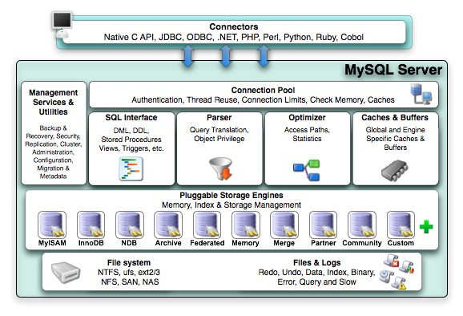**MySQL architecture with pluggable storage engines –**

[Fig. 2.2.1 MySQL Architecture With Pluggable Storage Engines][1.[5]]

The pluggable storage engine architecture provides a standard set of management and support services that are common among all underlying storage engines. The storage engines themselves are the components of the database server that actually perform actions on the underlying data that is maintained at the physical server level.

This efficient and modular architecture provides huge benefits for those wishing to specifically target a particular application need—such as data warehousing, transaction processing, or high availability situations—while enjoying the advantage of utilizing a set of interfaces and services that are independent of anyone one storage engine.

The application programmer and dba interact with the MySQL database through connector APIs and service layers that are above the storage engines. If application changes bring about requirements that demand the underlying storage engine change, or that one or more storage engines be added to support new needs, no significant coding or process changes are required to make things work. The MySQL server architecture shields the application from the underlying complexity of the storage engine by presenting a consistent and easy-to-use api that applies across storage engines.

* + 1. **Features of MySQL[1.[2][3]]**
* **Relational database system –**

Like almost all other database systems on the market, MySQL is a relational database system.

* **Server architecture –**

MySQL is a client/server system. There is a database server ( MySQL ) and arbitrarily many clients ( application programs ), which communicate with the server that is, they query data, save changes, etc. The clients can run on the same computer as the server or on another computer (communication via a local network or the internet).

* **SQL compatibility –**

MySQL supports as its database language - as its name suggests – sql (structured query language). Sql is a standardized language for querying and updating data and for the administration of a database. There are several sql dialects (about as many as there are database systems). MySQL adheres to the current sql standard (at the moment sql: 2003), although with significant restrictions and a large number of extensions.

* **Storing procedures –**

Here we are dealing with sql code that is stored in the database system. Stored procedures (sps for short) are generally used to simplify certain steps, such as inserting or deleting a data record. For client programmers, this has the advantage that they do not have to process the tables directly, but can rely on SPS. Like views, SPS help in the administration of large database projects. SPS can also increase efficiency. MySQL has supported SPS since version 5.0.

* **Foreign key constraints –**

These are rules that ensure that there are no cross-references in linked tables that lead to nowhere. MySQL supports foreign key constraints for InnoDB tables.

* **Platform independence –**

It is not only client applications that run under a variety of operating systems MySQL itself (that is, the server) can be executed under a number of operating systems. The most important are apple macintosh os x, Linux, Microsoft windows, and the countless UNIX variants.

**CHAPTER 3: EXISTING SYSTEM**

* 1. **SYSTEM COMPONENTS**
     1. **Features of the system components**
* **New member registration –**

This component used to register new members in the website database. Using this interface website can introduce new members to the website as well members can modify their detail to the database.

* + 1. **Admin**
* **Manage members –**

This component is used for managing members of the website so that keep track of members. Admin has full rights to removing members and also for seeing members’ information.

* **Manage categories –**

This component is used for managing categories of the business so that entry of the business and all management should be easily done by the admin.

* **Manage subcategories –**

This component is used to manage subcategories of the categories for further management of the categories-wise nested data.

* **Manage business material –**

This component is used to manage business material of the business details so that entry of the business and all management should be easily done by the admin.

* **Manage work –**

This component is used to manage the work of the business so that entry of the business and all management should be easily done by the admin.

* **Manage District/City –**

This component is used to manage the district/city of the business so that entry of the business and all management should be easily done by the admin.

* **Manage business details –**

This component is used to manage all the business details along with their description, business view, open & close time, business gallery, and business profile picture management.

* **Manage business images –**

This component is used for managing business images of the business so that entry of the business images and all management should be easily done by the admin.

* **Manage review –**

This component is used for managing the review of the business so that entry of the review is activated/deactivated and all management should be easily done by the admin.

* + 1. **Web User**
* **Web user management –**

This component is used for web-user to view information of the business it has the right for registration so that it can become a business member of the website so that it can use and facility other options of the website.

* 1. **DRAWBACKS OF EXISTING SYSTEM**
* Their existing system was limited only to business and so they want to introduces new things to their existing system.
* They have no limitation in the existing system that other new supplier can add new business to the site but now they manages supplier to introduce new business.
* They have limited categories of the business.

# CHAPTER 4: SYSTEM PLANNING

### FEASIBILITY STUDY[1.[3]]

* **Technical feasibility**

This website does require much higher & advanced technology. It requires database interaction and it also requires to be accessed via the web or internet. This can be easily done. Also, these should be a facility for online business and also a view for the particular business online. We are sending all the business information with all business attributes so the business members can have reliable navigation and make the proper decision for adding a business. It must be developed within the three months of period excluding the time period for the testing, and validation. And verification. Thus it seems that the project is technically feasible to do.

* **Economical feasibility**

In this project, we will require to have an internet connection for a better online website. Such at the developer end it needs a good server with a high capacity of ram and CPU processors so can it can handle lots of members an at a time online communications, as it will be web-enabled we do not have any extra cost of setting up a network. This is also feasible economically.

* **Operational feasibility**

The new system can be beneficial only if it satisfies the organization’s requirements, in such a way that resource utilization and the optimum outcome are is justified. A new system should not only be robust but should also be able to work simultaneously with other systems. Operational feasibility means that a new system should not affect any existing system during the development phase or even in the implementation phase. Following are some points underlying the operational feasibility of the system- as the development proceeded many doubts got cleared out.

Our project guide – Prof. Poonam Chakravarty is guided us to take proper care and check for the operational feasibility of the system.

Efforts were made to optimize the human efforts in data collection, storage, retrieval, security, and presentation.

The proposed system made its best efforts in achieving the necessary function and performance, as required by the user and keeping in mind some infrastructure constraints.

**4.2 REQUIREMENT ANALYSIS AND DATA GATHERING[1.[1][2]]**

* + 1. **Requirement gathering**
* Before developing an elegant software, the best way to identify basic needs and functionality is to take an interview with the director and management who are working in that specific area addressed by the proposed application.
* For gathering basic needs and functionalities, we had a meeting with Guide personally to understand required functionalities, also noted down some useful features to be included.
* By analyzing the information we understand the following process requirement for security systems.

* + 1. **Understanding the process of security system**
* What type of forms should be included?
* How to manage all forms?
* How to manage the reminder process?
* How to manage the login and logout process?
* How to manage all forms linked with each other?
* How to manage inter-communication with the internet?
* How many answers and programs are submitted online?
* How to manage the bunch of data of a particular member so that it can have a security purpose and keep the data private?
* How to manage all the members online and care for them offline?
* How to perform all member’s security levels and perform authentication and give a person account to each member for security purposes?

* + 1. **Understand different type of user who uses this website**
* How many members are going to use this website?
* What is the knowledge level of the member and how does it maintain the business criteria?
* Provide authorization and separate their functionality?
  + 1. **Requirement analysis**
* We analyzed our gathered information and we have decided our system should have the following functionalities.
  + 1. **Authentication of members** 
       - * Creation of member’s account
         * Deletion of member’s account
         * Authorization of member account
         * Admin
         * Admin
         * Member
    2. **Different types of module**
* Login
* Business management
* Profile management
* Account management
* Member management
  + 1. **Member** 
       - * Login
         * Member registration
         * View business
         * Account management
         * Business details
         * Review
         * Get business detail with different type
         * Rating
    2. **Admin** 
       - * Business Management
         * District/City Management
         * Visitor Management
         * Member Management

# 

# CHAPTER 5: PROPOSED SYSTEM

**5.1 SCOPE**

* **Main aim of the system**

The website provides a way for online business by viewing different businesses and online business allows the visitor to shop at the convenience of their own home, and to save traveling time to retail stores business and spend their time on other important tasks and hobbies.

* + 1. **Scope of system**
* Website can able to manage the members.
* Website can able to provide the best security level to the members of the site for authenticate members online.
* Website is able to introduce new schemes that can attract businesses for grow your business.
* Consumers are freed from the pressure to buy from the vendors and can spend more time making wise purchase decisions.
* The computerized system names ―online business such easier and faster it has solved problem for business management, automated profile maintains, reduce paper work done by existing system, reduce some entry work in system.
* Website is also good at the security level means that the web-user or other unauthorized web user will not be able to get all details of the members.
* Website gives the best way for the registration of new members and join the portal. 
  1. **OBJECTIVES**
* **Objective of the system**

Consumers desire a variety of businesses because they look for the right business that will fully satisfy them. There is an infinite variety of businesses available online because visitors browse through the show the business. They are made all around the world without geographical boundaries. The system allows the owner to manage all kinds of categories and maintain suppliers for each business.

With the online business that enables business comparison, visitors can compare business to another business and features to make a better decision with less effort.

**5.3 CONSTRAINTS**

The constraint associated with the development of any software system includes those that are common to all systems. The common constraints may include lack of managerial participation tighter development schedule etc.

Some of the constraints are listed below with which we have developed this system:

* User mistakes can be turned in the improper answer.
* The common constraints may include lack of managerial participation tighter development schedule frequently working for management etc.
* It has some specifications needed to run this software because is developed in PHP with Linux.
* Net connection and other web-related software are required.

**5.4 EXPECTED ADVANTAGES**

* **High security**

There is a high-security mechanism provided by the proposed system. No unauthorized person can make a change in the data those are stored in website. Only authorized person can change & also can make login.

* **Less time required**

In our website, all the processes are carried out by computer so obviously it will require a more traditional inventory system in that sense, it will require less time to complete transactions and can process data very fast.

* **High amount of accuracy**

In our web system, there are less amount of human activities are involved in that case it will have less effect in our accounts. The website will perform all calculation and manipulation automatically; in that case, the data that we receive will be accurate and much more reliable than the data generated previously.

* **Easy to use**

Online saree shopping is accessible round the clock. You can buy whatever you want even at 3 a.m. In the morning. You can choose from a wider variety of things available for you to shop for which may not be available in the local brick and mortar stores. You also have the benefit of to do all from the comfort of your own home. When you buy from online store you have the comfort to take your time while checking for the things of your choice, this will lead you to a simple and quick way to perform price comparison unlike the dissatisfied and hurried shopping you do in the local stores.

**CHAPTER 6: DETAIL PLANNING**

**6.1 DATA FLOW DIAGRAM[1.[4]]**

The data flow diagrams are an intuitive way of showing how data is processed by a system. The symbols used in the dfd for this project are shown, bellow.

1. Data Flow:

Following symbol is used to show data flow. The data flow is a packet of data.

1. Processes people, procedures, or devices that use or produce data:

1. Source or destination of data:

These are the entities, which interact with the system from outside its boundaries.

1. Data storage:

Here data are stored or referenced process in the system.

In the DFD diagram, we define the flow of data and how the system data flow is managed by grouping the data with theentity-relationship. In this way, we find out the, need of the system and managed it in a particular way by which we can easily access with the system. By the use of the DFD diagram, all the complete data flow is understood by the system analysis. Here in our DFD.

* **0 Level DFD Of Cubics Business: [1.[6]]**

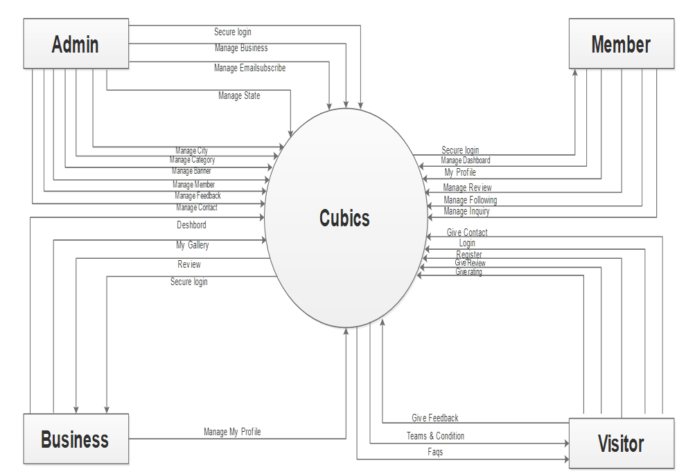

0.0

[Fig. 6.1.1 Zero Level DFD]

* **1st Level Diagram Of Cubics Business[1.[6]]**

[Fig. 6.1.2 1st Level DFD]

* **2nd Level Diagram[1.[6]]**

1. **Login Process**



[Fig. 6.1.3.1 2nd Level DFD Login Process]

1. **Registration Process**

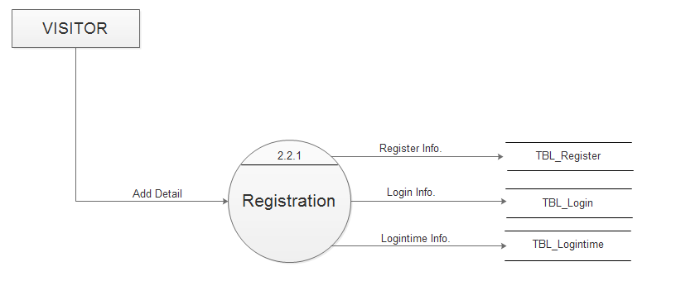

[Fig. 6.1.3.2 2nd Level DFD Registration Process]

1. **Location Process**

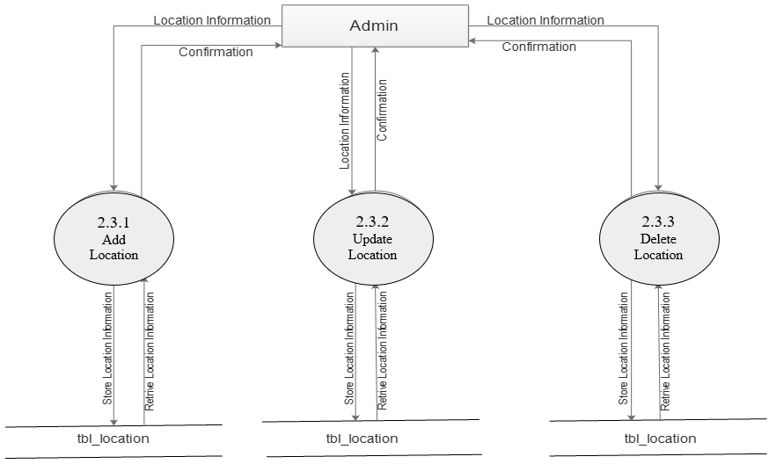

[Fig. 6.1.3.3 2nd Level DFD Location Process]

1. **Review Process**



[Fig. 6.1.3.4 2nd Level DFD Review Process]

1. **Category Process**

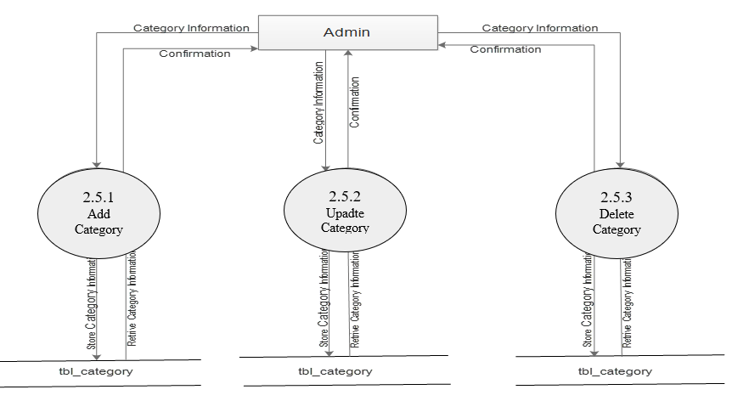

[Fig. 6.1.3.5 2nd Level DFD Category Process]

1. 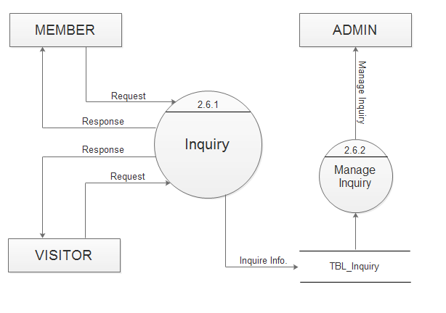**Inquiry Process**

[Fig. 6.1.3.6 2nd Level DFD Inquiry Process]

1. 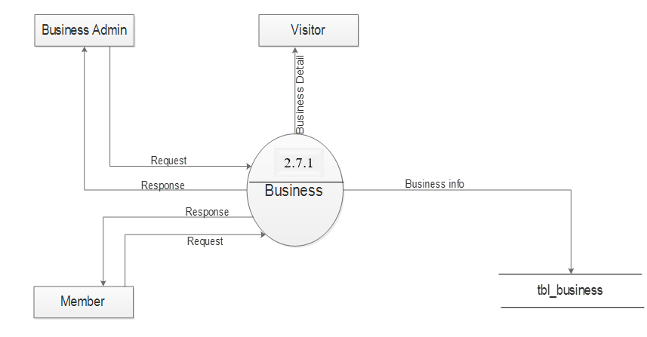**Business Flow**

[Fig. 6.1.3.7 2nd Level DFD Business Flow]

**6.2 PROCESS SPECIFICATION[1.[6]]**

1. **Login Process**

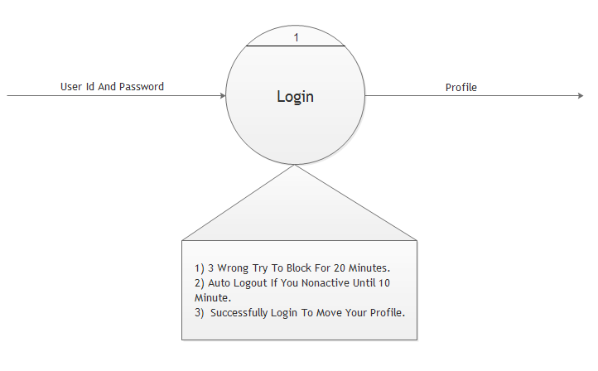

[Fig. 6.2.1 Login Process]

1. **Registration Process**

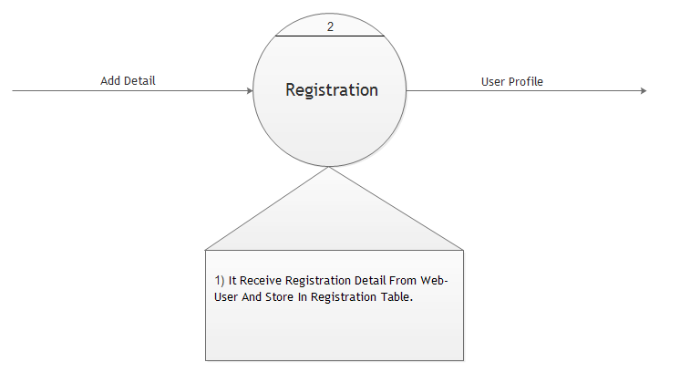

[Fig. 6.2.2 Registration Process]

1. **Location Process**



3

[Fig. 6.2.3 Location Process]

1. **Review Process**

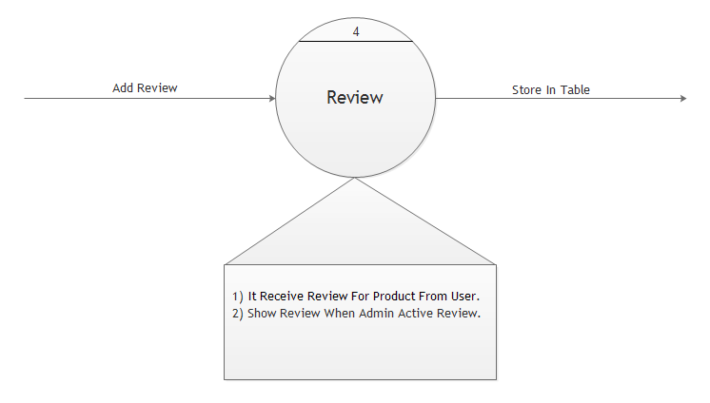[Fig. 6.2.4 Review Process]

1. 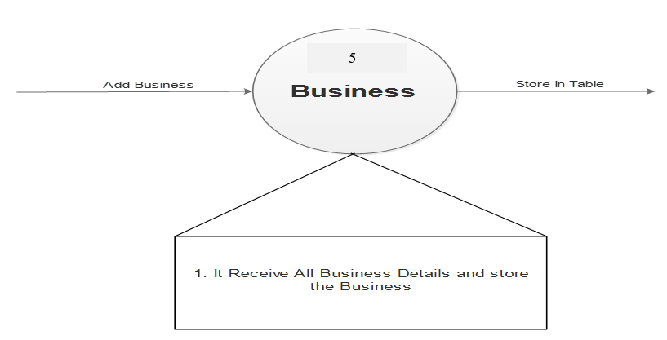**Business Process**

[Fig. 6.2.5 Business Process]

1. 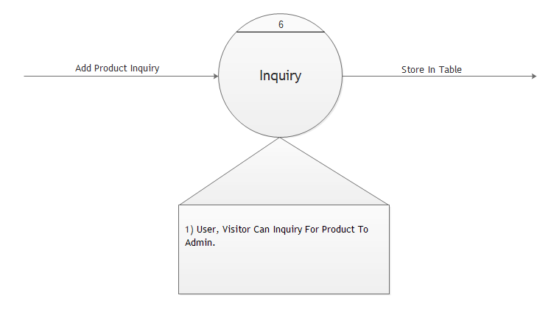**Inquiry Process**

[Fig. 6.2.6 Inquiry Process]

**6.3 UML[1.[6]]**

1. 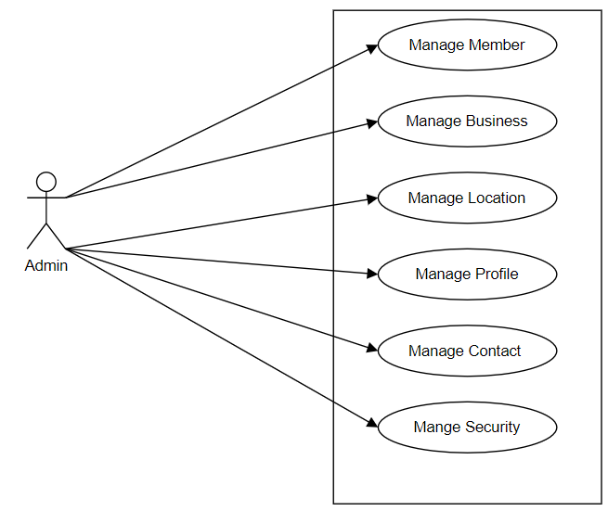**Usecase Admin**

[Fig. 6.3.1 Usecase Admin]

1. 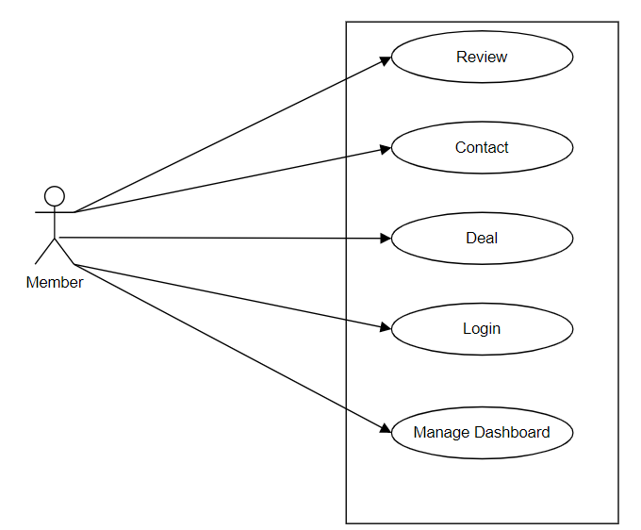**Usecase Member**

[Fig. 6.3.2 Usecase Member]

1. 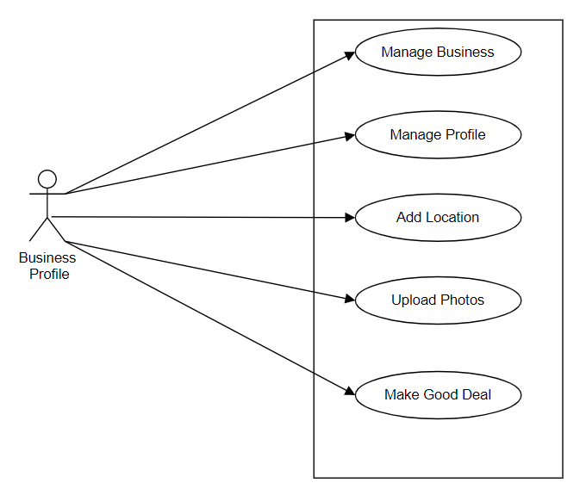**Usecase Business**

[Fig. 6.3.3 Usecase Business]

1. 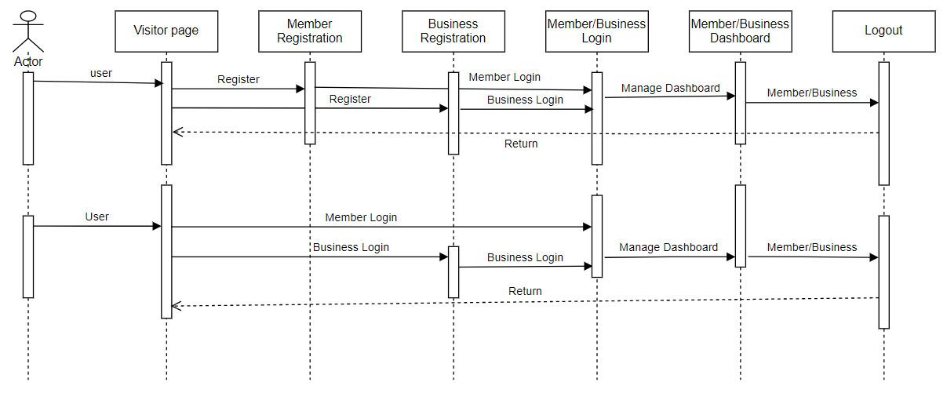**Sequence Diagram**

[Fig. 6.3.4 Sequence Diagram]

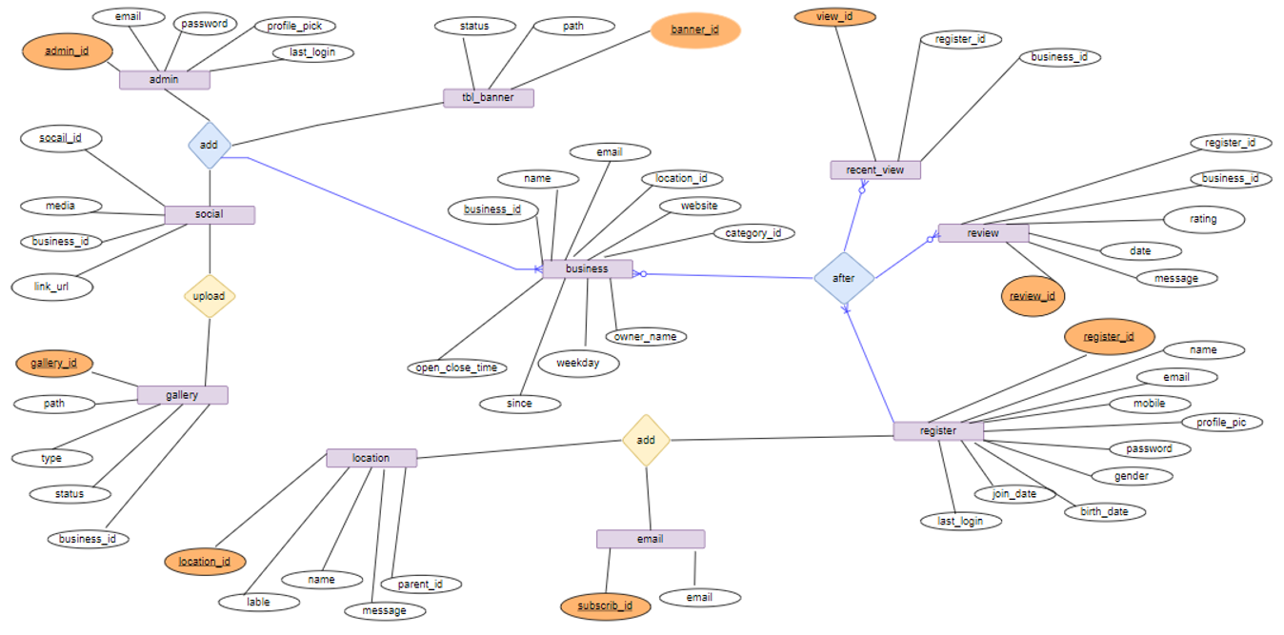**6.4 E-R DIAGRAM[1.[6]]**

[Fig. 6.4 E-R Diagarm]

**6.5 DATA DICTIONARY[1.[6]]**

### Table Name: Registration

### [Table 6.5.1 Registration]

### Table Name: Login

[Table 6.5.2 Login]

### 

### Table Name: Contact_Us

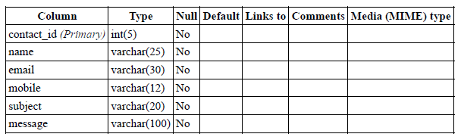

[Table 6.5.3 Contact]

### 

### Table Name: Inquiry

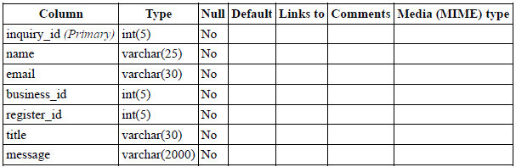

### [Table 6.5.4 Inquiry]

### Table Name: Feedback

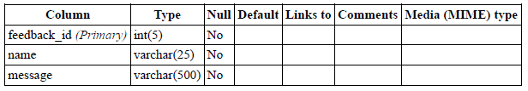

[Table 6.5.5 Feedback]

### 

### Table Name: Email Subscriber

### 

### [Table 6.5.6 Email Subscriber]

### Table Name: Banner

### [Table 6.5.7 Banner]

### 

### Table Name: Main Category

### [Table 6.5.8 Main Category]

### 

### Table Name: Review

[Table 6.5.9 Review]

### Table Name: Business

### [Table 6.5.10 Business]

**6.6 PAGES**

* **Static Page:**

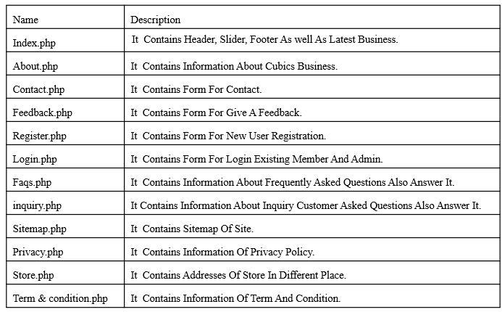

[Table 6.6.1 Static Page]

* **Dynamic Page:**

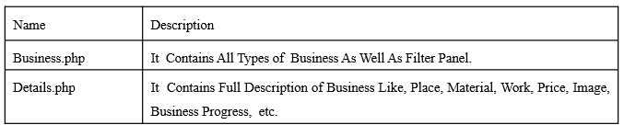

[Table 6.6.2 Dynamic Page]

# CHAPTER 7: PROJECT SCREENSHOTS

**7.1 WEBSITE SCREENSHOTS**

**VISITER**

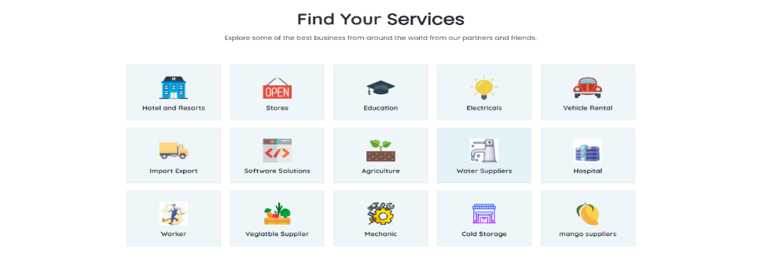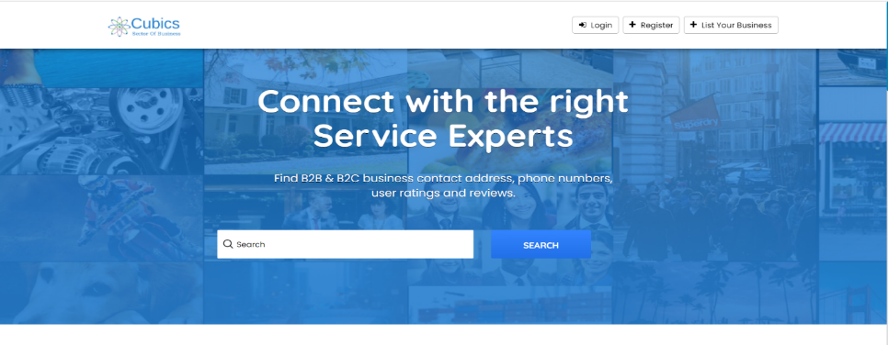

[Fig. **7**.1.1 Home Page]

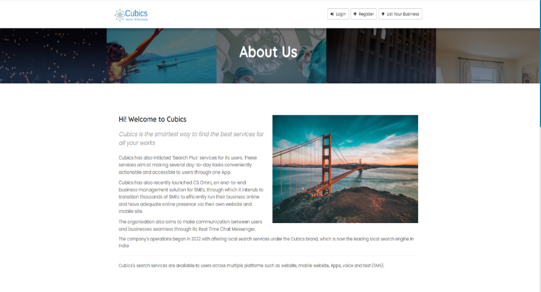[Fig. 7.1.2 About Us]

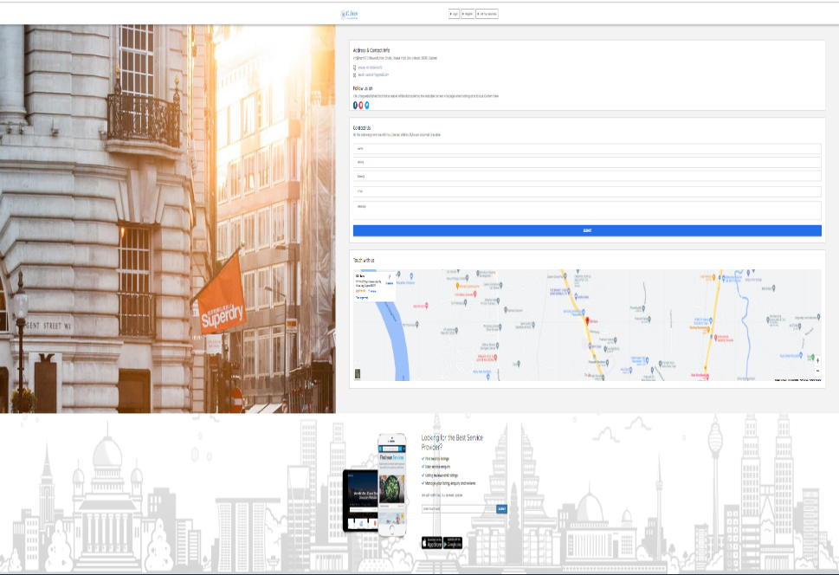

[Fig. 7.1.3 Contact Us]

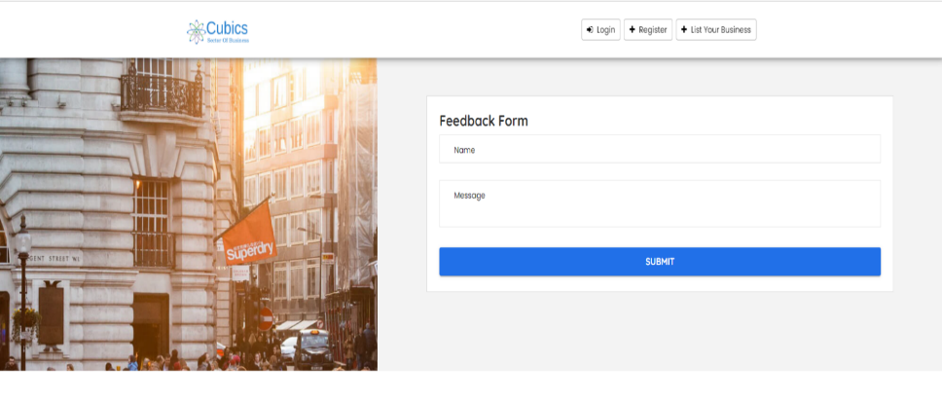[Fig. 7.1.4 Feedback Form]

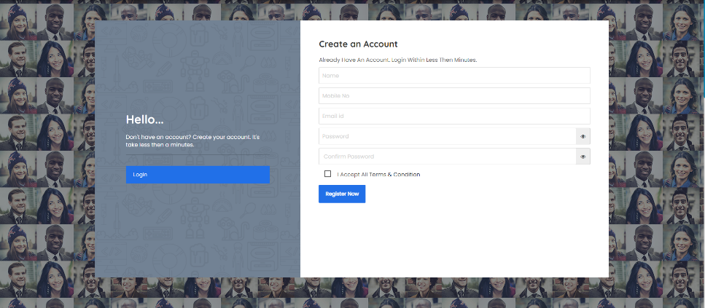

[Fig. 7.1.5 Register Form]

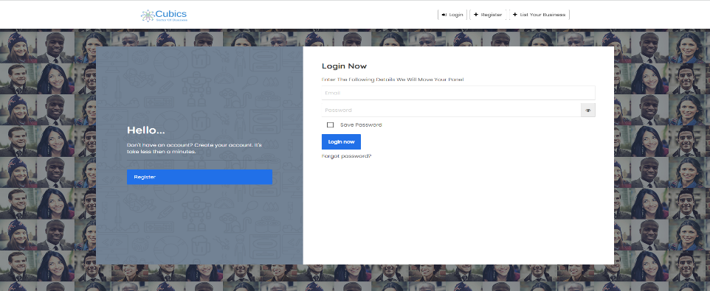

[Fig. 7.1.6 Login Form]

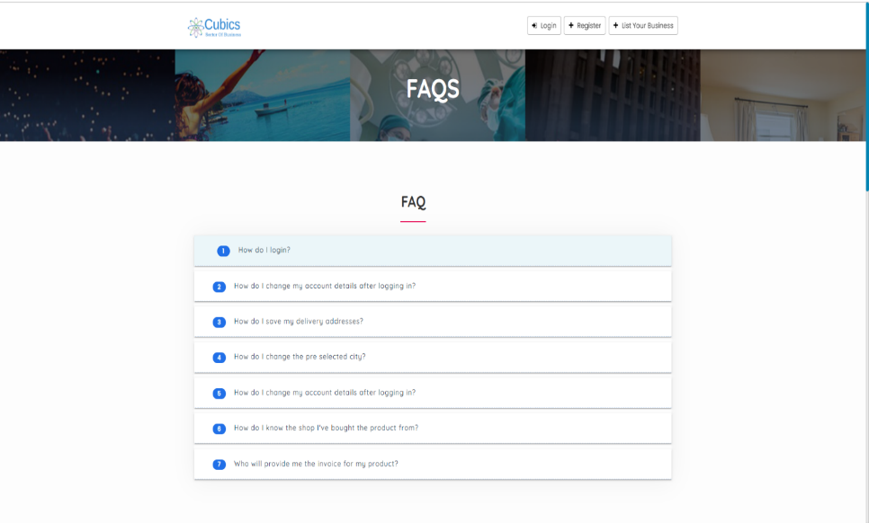[Fig. 7.1.7 FAQ’S]

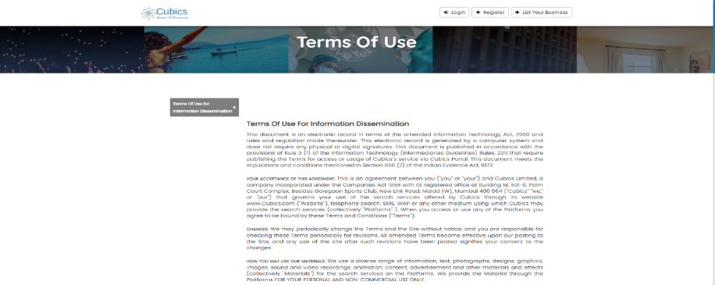

[Fig. 7.1.8 Terms Of Use]

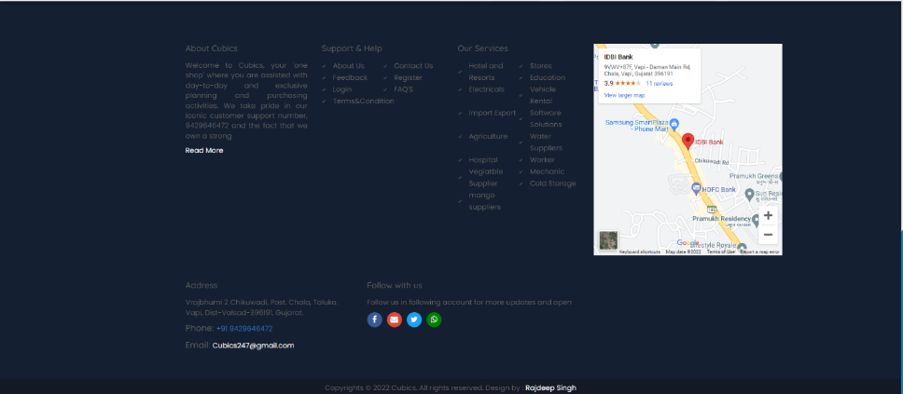[Fig. 7.1.9 Footer]

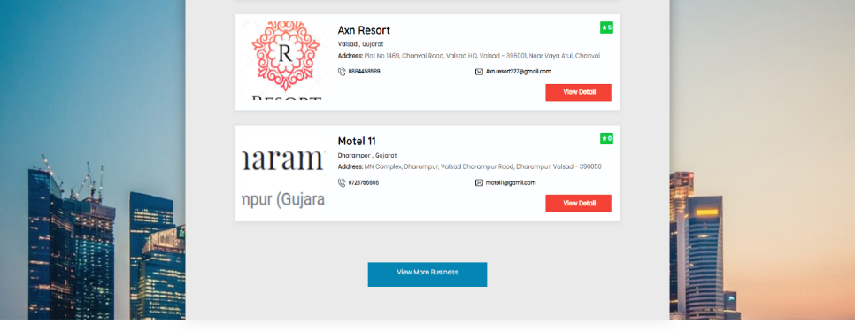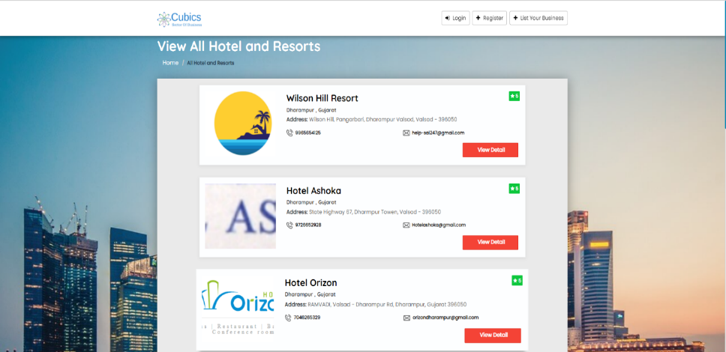

[Fig. 7.1.10 View All Business]

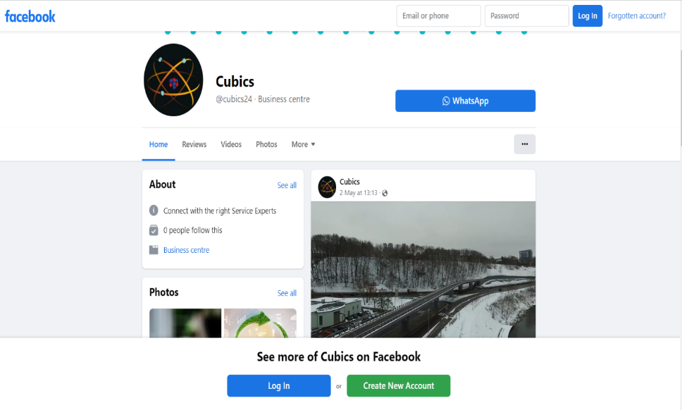[Fig. 7.1.11 Facebook Page]

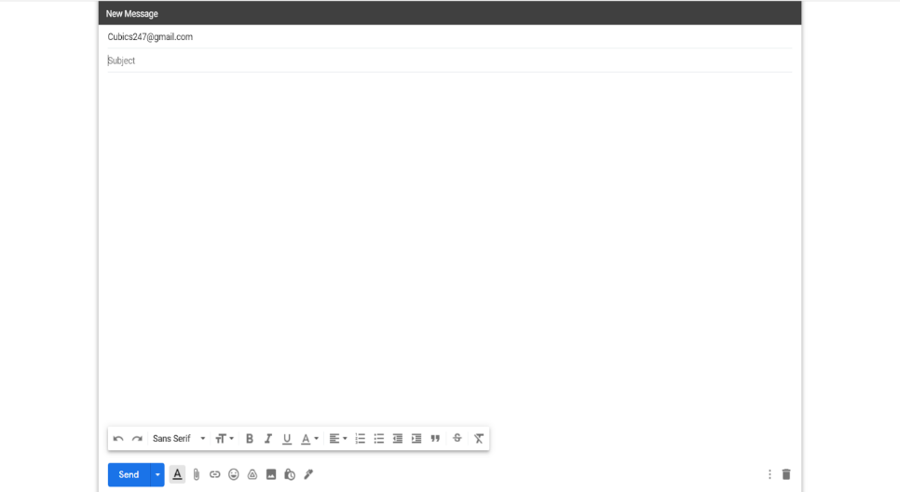

[Fig. 7.1.12 Gmail Page]

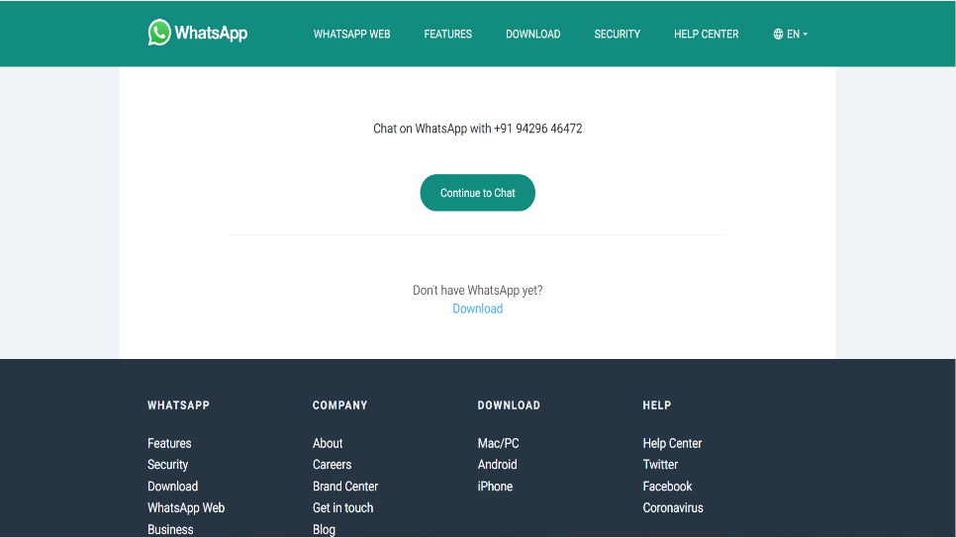

[Fig. 7.1 13 WhatsApp Page]

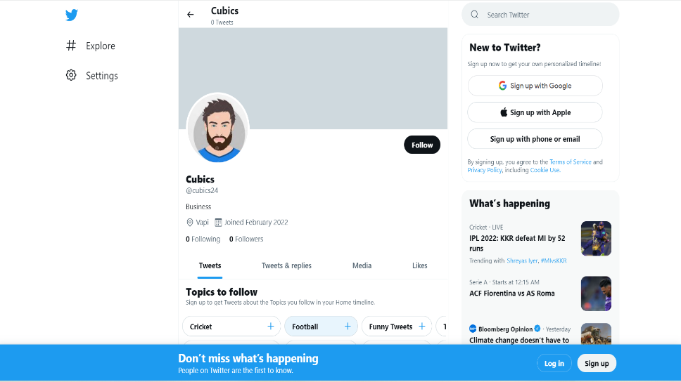

[Fig. 7.1.14 Twitter Page]

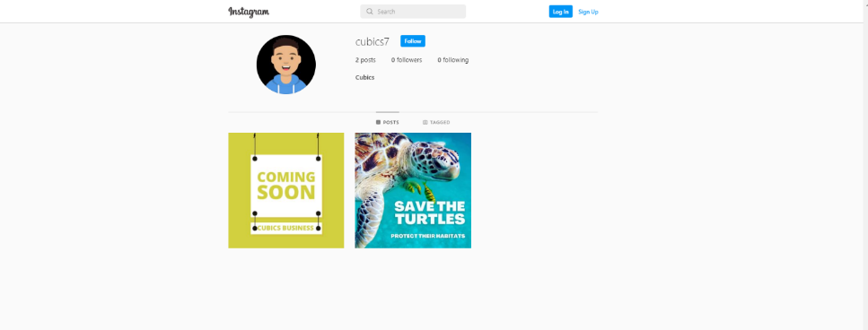

[Fig. 7.1.15 Instagram ]

**MEMBER**

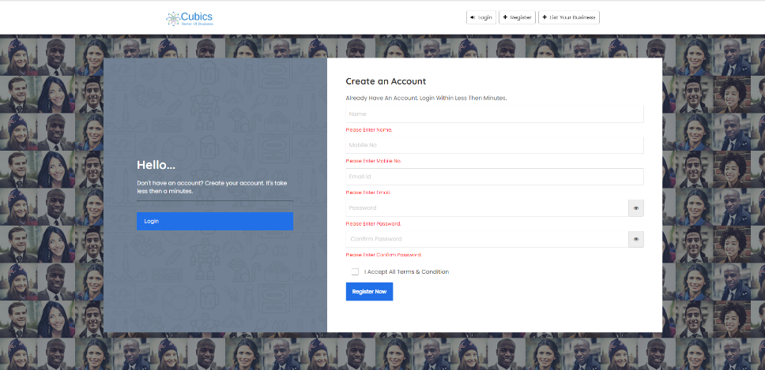

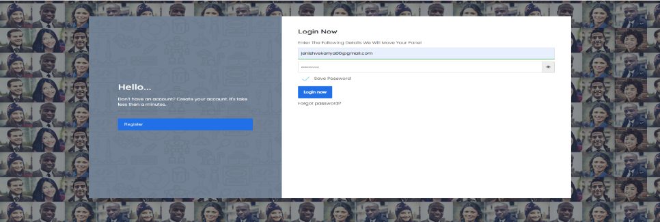[Fig. 7.1.16 Validation Registration page]

[Fig. 7.1.17 Login Page]

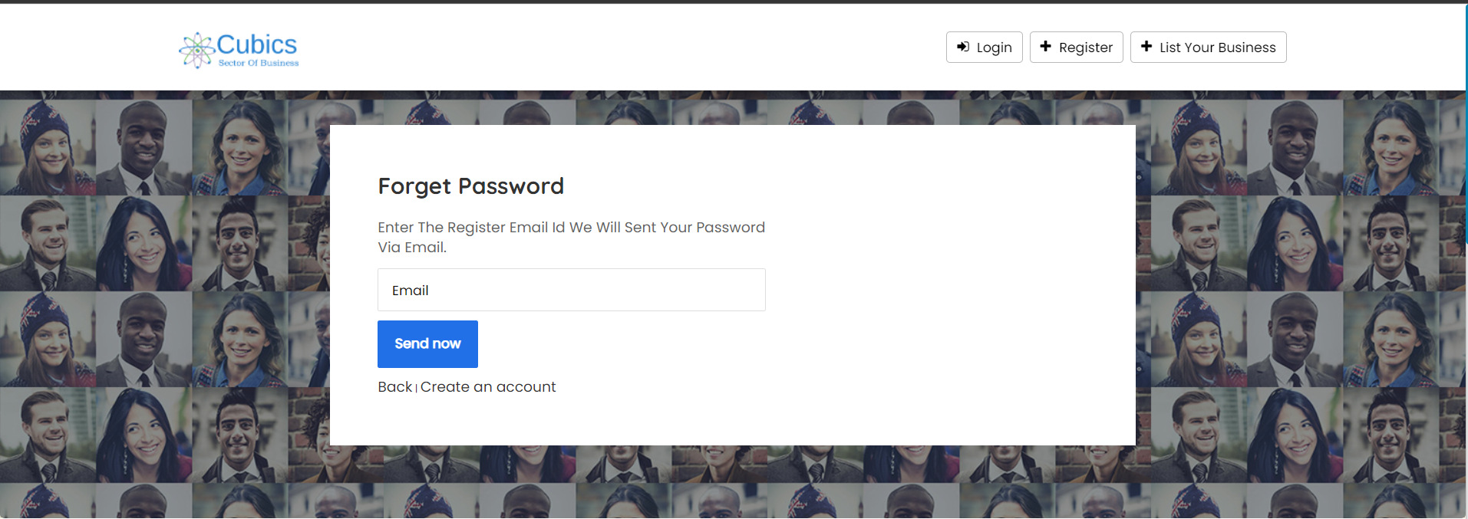

[Fig. 7.1.18 Forgot password]

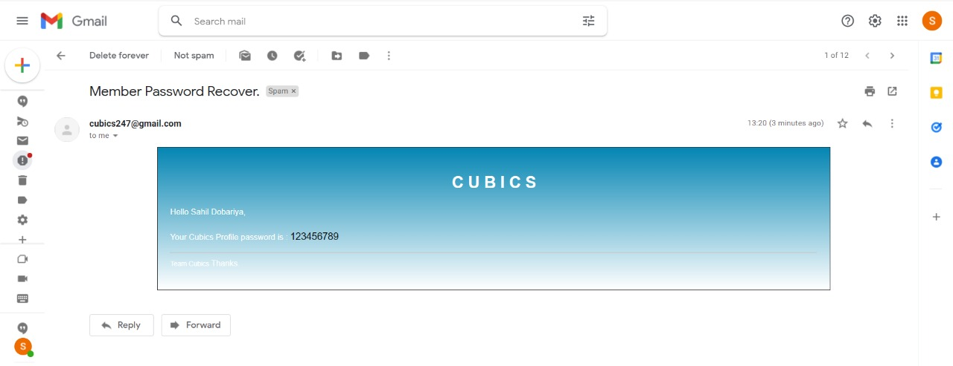

[Fig. 7.1.19 Forgot password mail reply]

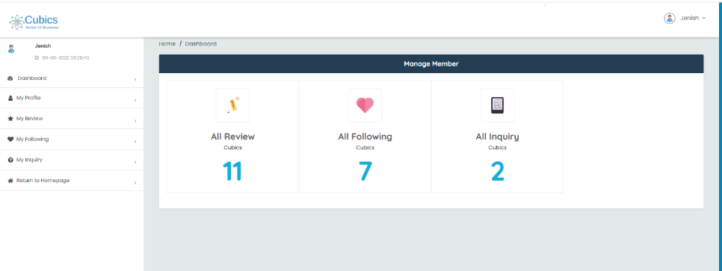

[Fig. 7.1.20 Dashboard]

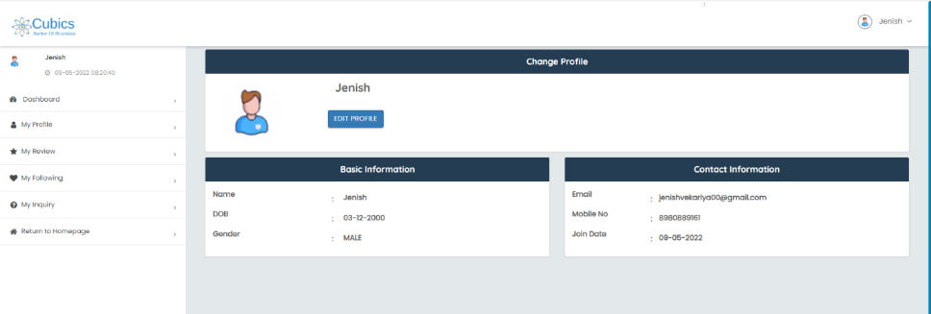

[Fig. 7.1.21 Profile]

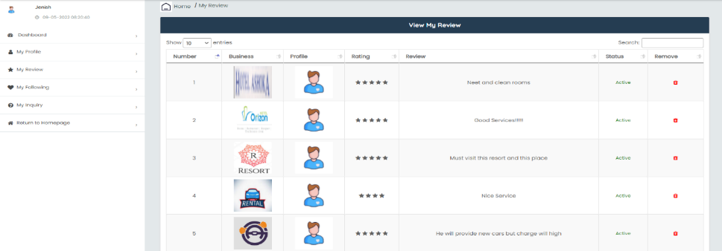[Fig. 7.1.22 Reviews]

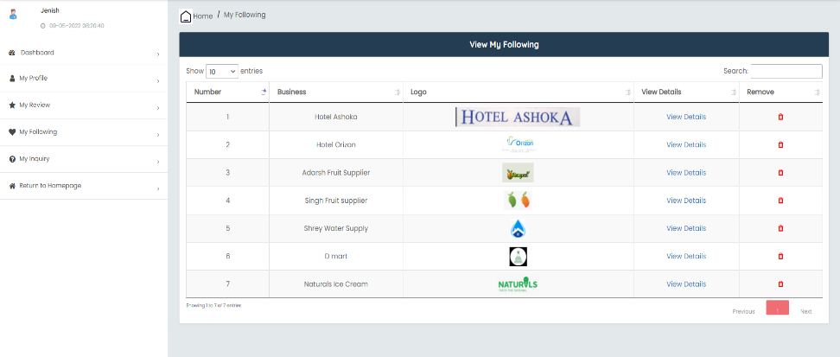

[Fig. 7.1.23 Follow]

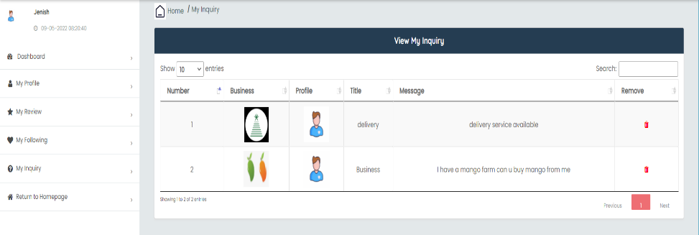

[Fig. 7.1.24 Inquiry]

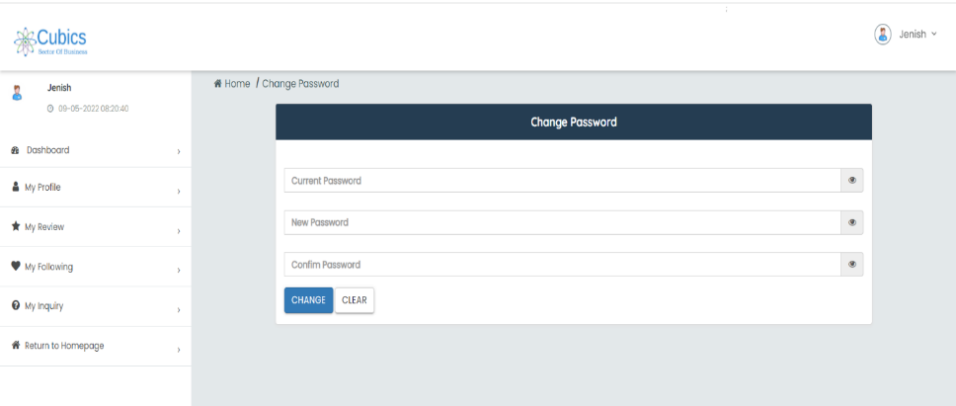

[Fig. 7.1.25 Change Password]

**BUSINESS**

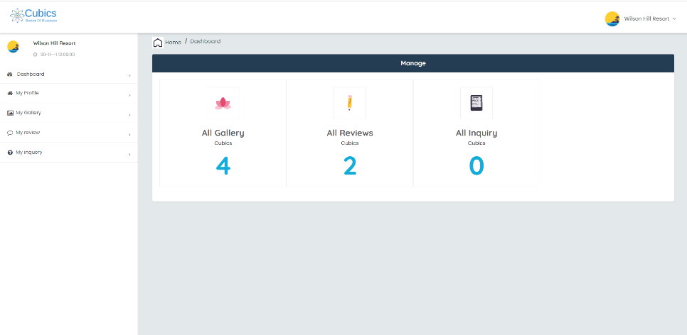

[Fig. 7.1.26 Business Dashboard]

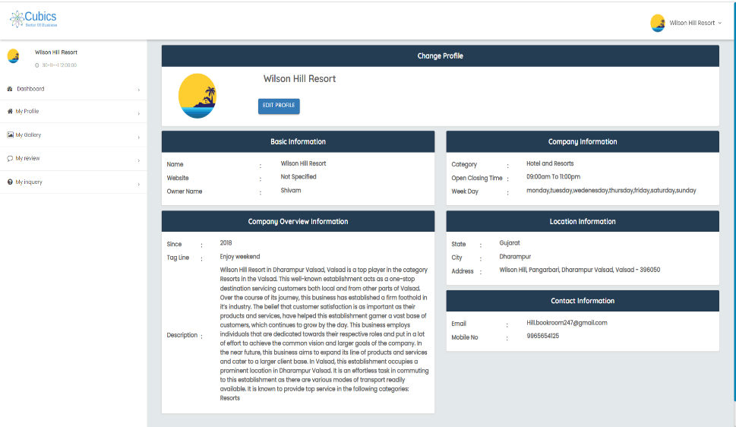

[Fig. 7.1.27 Business Profile]

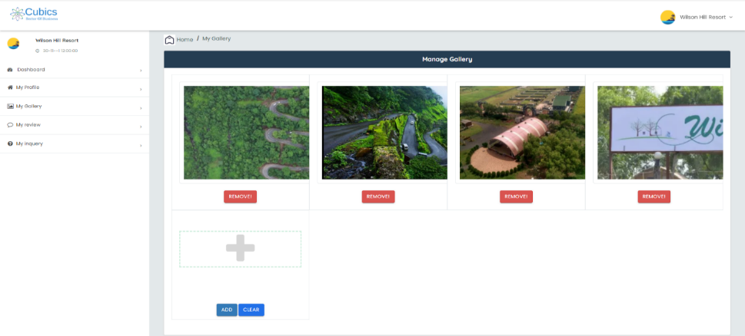

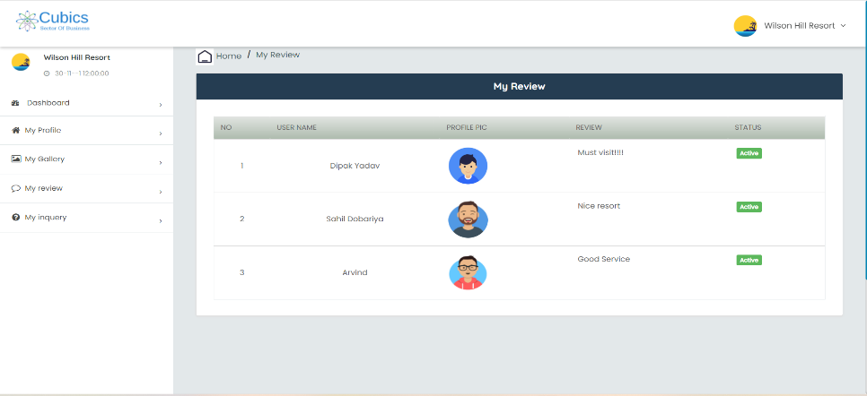[Fig. 7.1.28 Gallery]

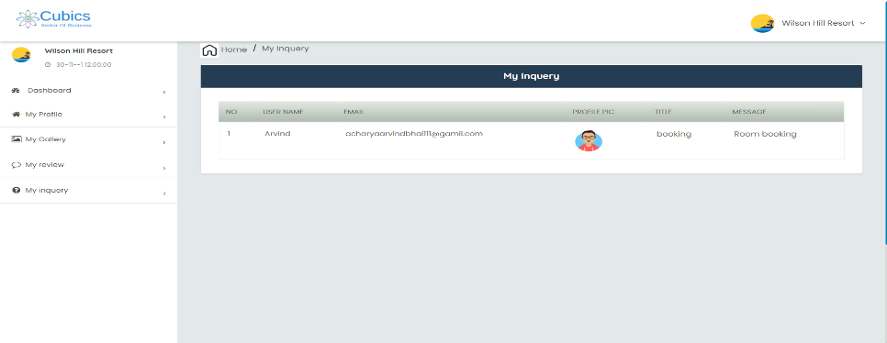

[Fig. 7.1.29 Business Review]

[Fig. 7.1.30 Business Inquiry]

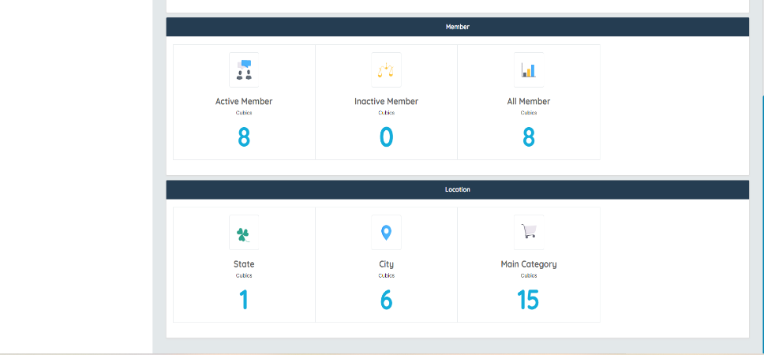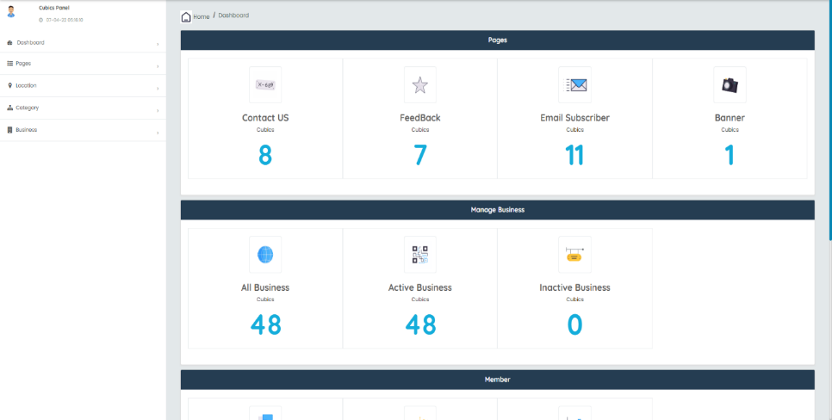**ADMIN**

[Fig. 7.1.31 Admin Dashboard]

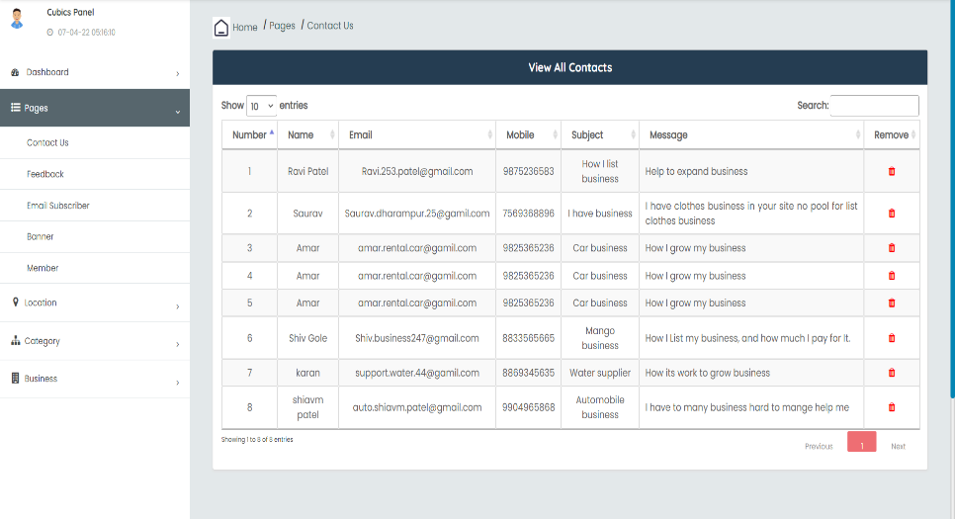

[Fig. 7.1.32 All Members Contact Us]

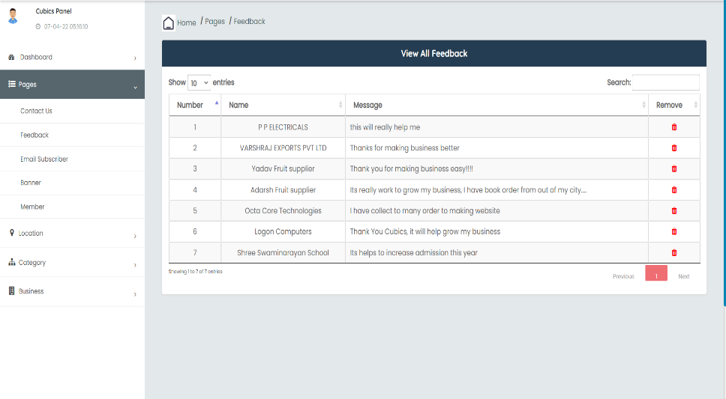

[Fig. 7.1.33 All Members Feedback]

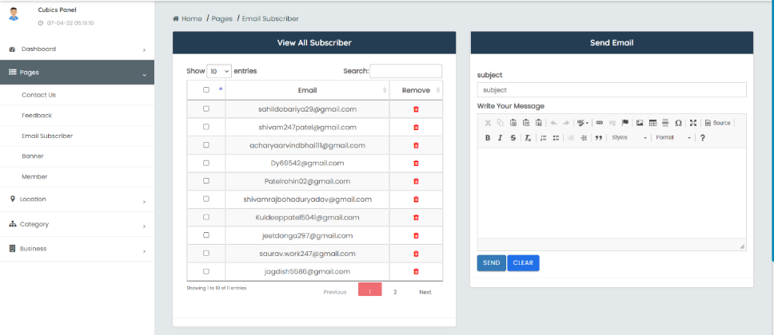

[Fig. 7.1.34 Email Subscriber]

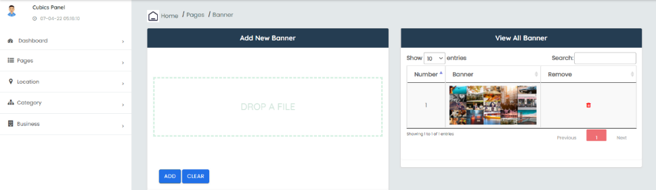

[Fig. 7.1.35 Banner]

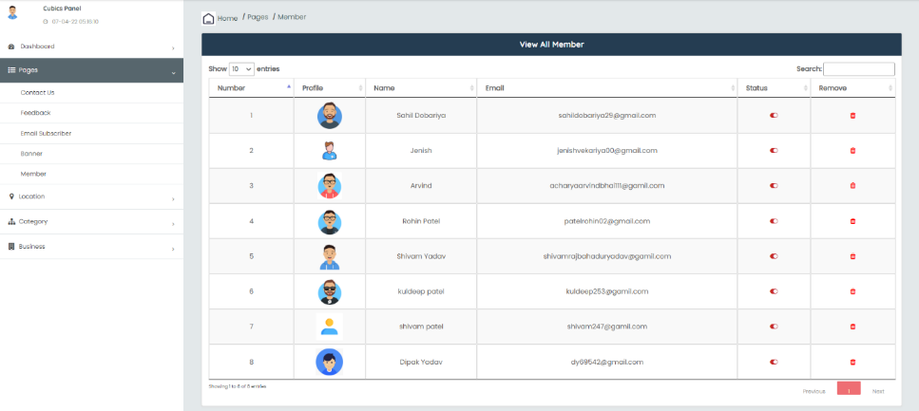

[Fig. 7.1.36 Member Login]

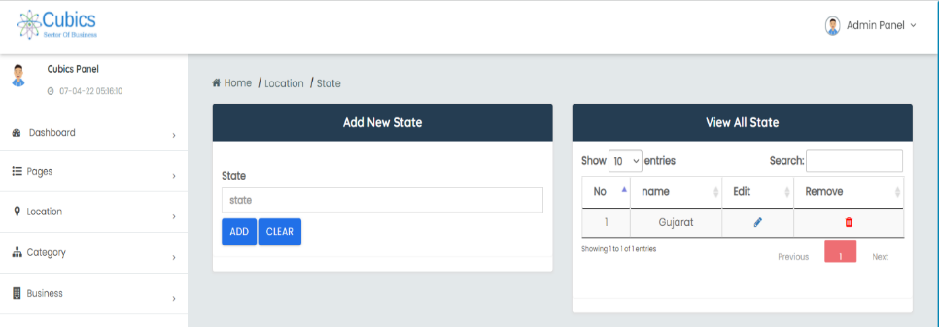

[Fig. 7.1.37 Add State]

[Fig. 7.1.38 Add City]

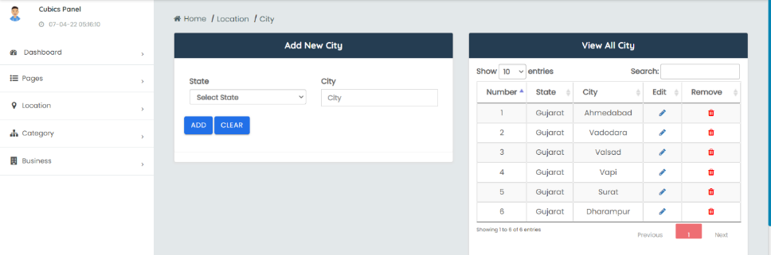

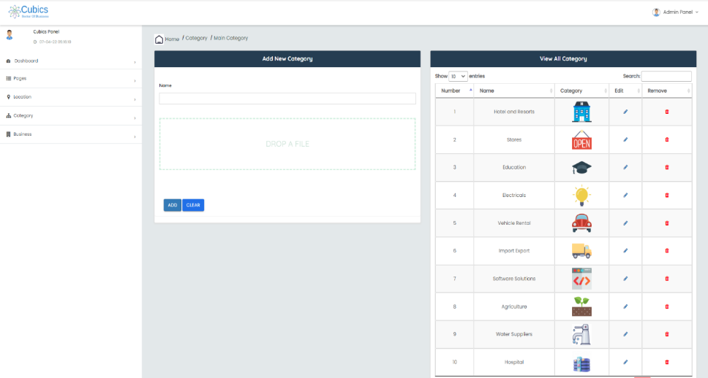

[Fig. 7.1.39 Business Category

# REFERENCE

1. **Websites**
2. <https://www.stackoverflow.com>
3. <https://dev.mysql.com/>
4. <http://www.google.com>
5. [http://www.w3schools.com](http://www.w3schools.com/)
6. <https://www.tutorialspoint.com/php>
7. http://www.undrawio.com
8. **Books**
9. HTML And CSS
10. PHP 5 Power Programming
11. PHP/MySQL
12. PHP Manual